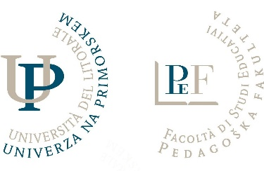
We invite you to
19th International Scientific Meeting organized by
The University of Primorska, Faculty of Education,
in cooperation with the University of Kragujevac, the Faculty of Education in Užice and Jagodina (Serbia) and the University of Maribor, Faculty of Education,
titled
Education and training from the perspective of the past, present and future,
which will be on Friday, September 15, 2023,
at the University of Primorska, Faculty of Education, Cankarjeva 5 in Koper.

When planning for the future, we look to the past. Education and upbringing are faced with the challenges of socioeconomic conditions, current policies and the challenges of predicting the competence of young people after completing school. At the international scientific meeting, we want to encourage a discussion that would shed light on educational issues in confronting the perspectives of the past and the future. How was and is education conceived for successful learning and promoting development in a rapidly advancing technological world? Theoretical traditions are built in different conceptual frameworks, which enable them to define fundamental concepts and principles. The coexistence of disciplines in the educational field enables fruitful discussion and new perspectives.
With the invitation to participate in an international scientific meeting, we are opening space to researchers who are ready to present their interests and research problems either from the perspective of the past, the future or between the past and the future. Empirical and theoretical contributions from different perspectives and theoretical bases are welcome, which shed light on the multiplicity of the school field, levels of education and training, stakeholders, processes, products and achievements that constitute challenges to research in education.
The international scientific meeting will contribute to thinking about the future of education. We are faced with the challenges of updating school and university educational programs, especially updating the education programs of teachers, educators, pedagogues and other pedagogical workers. This is also why it is necessary to think critically about what is possible and what to give priority to.

The purpose of the 18th international scientific meeting is to stimulate research and critical discussion about views on education and training in different periods and how these can contribute to the future of education and lifelong learning.

We look forward to professional discussions and cooperation with you.
Head of the Program Committee,
prof. Andreja Istenič, PhD

Important dates and information:
March 17, 2023 – deadline for registration and submission of the paper
April 28, 2023 – feedback to the author on the relevance of the paper
May 15, 2023 – deadline for submitting the final version of the paper
June 5, 2023 – feedback to the author about the acceptance of the paper
June 12, 2023 – deadline for payment of the registration fee

Registration fee: 100 Euros

Each author can register a maximum of two contributions as authorship or co-authorship. The editors will send only linguistically appropriate contributions to the peer review process, which will be formatted following the Guidelines for Formatting Contributions (Appendix).

Paper presentations will be held in a hybrid form, on the premises of the Faculty of Education and online.

Send contributions to the address: znanstveni.sestanek.pef@upr.si.

